**Lesson 07 Demo 1**

**Setting up Jinja2**

**Objective:** To install and set up Jinja2 in your system

**Prerequisites:** You need to have Python 2.7 or higher, minimum 8 GB RAM, and SSH or SCP communicator.

**Tools Required:** None

**Steps to be followed:**

1. Installing Jinja2

**Step 1: Installing Jinja2**

* 1. Use the command below to check and install the required dependencies for the packages you need:

**sudo apt-get update -y**

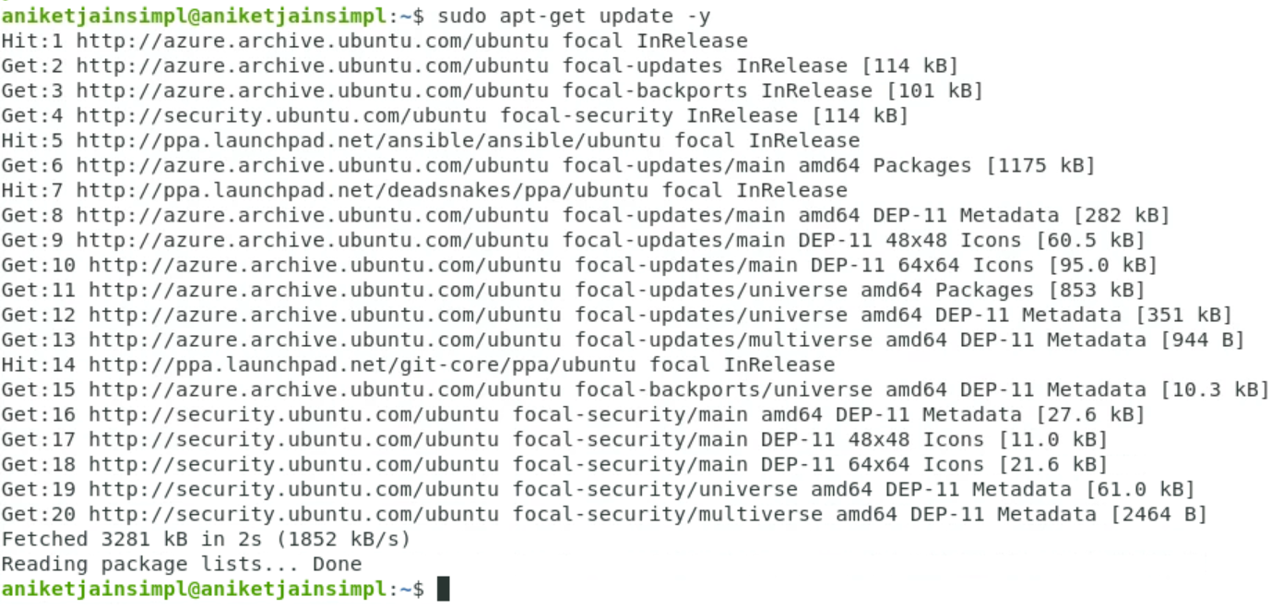

* 1. Run the install command with the -y flag to quickly install the packages and dependencies:

**sudo apt-get install -y python-jinja2**

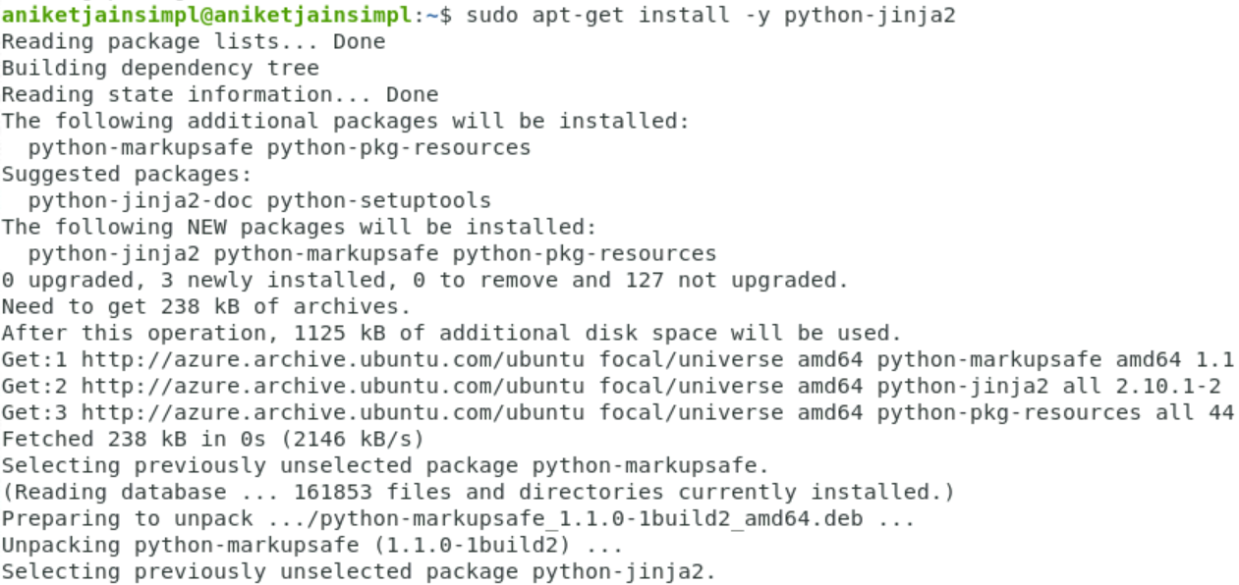

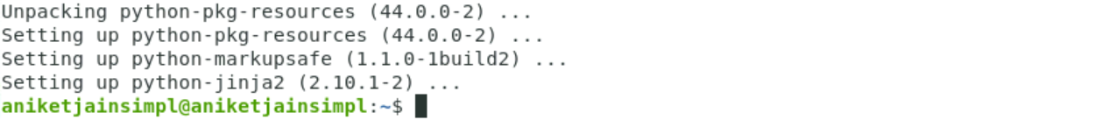

* 1. Check the system logs to confirm that jinja2 is installed successfully by performing the following command:

**dpkg-query -l | grep python-jinja2**

